**Introduction**

**Purpose:**

Our Initial Value Proposition (IVP) is that business, researchers, Post-Secondary Institutions (PSIs), private labs and government groups (funders, labs etc) have no centralized, well-developed method of matching solution providers with solution seekers.

**Scope:**

The platform will contain data on resources, (talent, space, equipment, software and hardware solutions / products) which will be matched with well-defined projects needing a solution.

**System Requirements**

**Functional Requirements:**

To support the user stories, our application has the following requirements. Others may exist, but we’ve identified and organized as many as possible here. This section summarizes the key components.

**SP.FR.001 Navigation**

The application must be able to provide navigation as described in the Application Design section above or in the design specification document created by the designer.

**SP.FR.002 Login**

Users must log in to the application using an email address and password. Password requirements should follow as reasonably possible the current best practices the Open Web Application Security Project ([OWASP](https://www.owasp.org/index.php/Authentication_Cheat_Sheet" \l "Implement_Proper_Password_Strength_Controls)) specifies.

**SP.FR.003 Forgot Password Process**

Users who forget their passwords can recover it using the [side channel token methodology](https://www.owasp.org/index.php/Forgot_Password_Cheat_Sheet) (link via email). For the purposes of the MVP we can skip the first step of identity confirmation using security questions as detailed in the specification linked above.

**SP.FR.004 User Profile Editing**

Logged-in users will be able to edit the content of their user profiles

* Name
  + First name
  + Last Name
* email address
* Office phone number
  + Field must allow for all different telephone number types to include country codes - for example +011, +1, etc
* Education
  + More than one field as some users may want to add several degrees to their profile
* Position (and any role-relative specifics)
* Languages spoken
* Experience Level (Junior / Senior / Expert)
* Categories of experience (as with profile creation on work-share communities, user will being typing and will be able to select from proffered choices) - industry classifications to be derived from [Standard Industrial Classifications](https://en.wikipedia.org/wiki/Standard_Industrial_Classification) <https://en.wikipedia.org/wiki/Standard_Industrial_Classification>

**SP.FR.005 Application Design**

Elements of application design will be as shown in the wireframes or the design specification document. We will require a responsive design layout. We intend to support desktop, laptop and tablets.

**SP.FR.006 User Administration Dashboard (Admin)**

The technical nature of the platform and its' user match-making process requires some level of admin oversight. This process needs a user administration dashboard to input user details and initiate the invitation process.

**Non Functional Requirements:**

**Performance :-** The website’s load time should not be more than one second for users.

**Reliability :-** Applicants can be able to access the website without failure.

**Availability :-** In case of unplanned system downtime, all features will be available after one working day.

**Recoverability :-** If the major incident happens on the website, it must take measures to go back to being fully operational within three days.

**Usability :-** The website’s interface has to be user friendly and easy to use.

**System Requirement**

**GCP(Google Cloud Platform) :-**

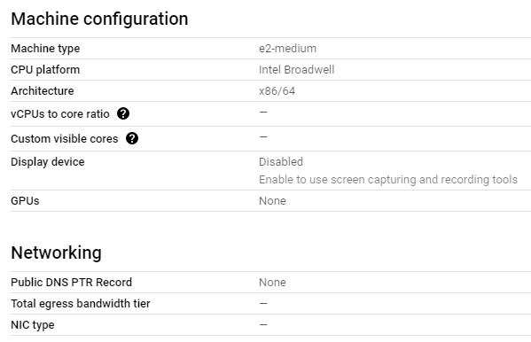

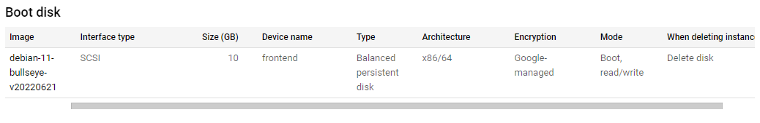

There are 3 VM’s with the same above given configurations :-

1. Dev
2. Alpha
3. Beta

**Cloudflare :-**

To use Cloudflare, you need to point the name servers for your domain to Cloudlare's ones.

The traffic is forwarded to the Cloudflare network, where it gets automatically filtered o prevent malicious traffic.

The name servers can be changed where you have registered the domain.

Cloudflare Name Servers:

NS ara.ns.cloudflare.com

NS chris.ns.cloudflare.com

DNS Record:

CNAME - www - thesciencepark.dev - Proxied - TTL(Auto)

A - thesciencepark.dev - 68.183.192.104 - Proxied - TTL(Auto)

A - alpha - 34.69.195.100 - Proxied - TTL(Auto)

A - beta - 34.172.105.190 - Proxied - TTL(Auto)

A - dev - 35.184.8.213 - Proxied - TTL(Auto)

SSL/TLS encryption mode is Flexible (Encrypts traffic between the browser and Cloudflare)